For office use only
Ref No. _______________________
Date Received___________________

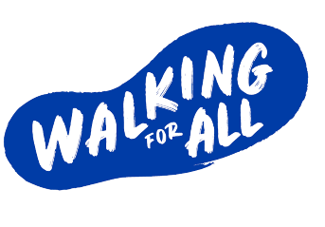


Equal Opportunity Monitoring Form
Completed monitoring form to be submitted, along with the application form, by email to wendy@out-scape.com.
Outscape does not discriminate on grounds of sex, marital status, religious belief, political opinion, race, age, sexual orientation or disability. We practise equality of opportunity in employment and select the best person for the job.
To demonstrate our commitment to equality of opportunity in employment we need to monitor the community background and sex of our employees, as required by the Fair Employment Act 1989.
Regardless of whether we practise our religion, most of us in Northern Ireland are seen as either Catholic or Protestant. We are therefore asking you to indicate your community background by ticking the appropriate box below.

POSITION Regional Manager East – Walking for All

Community Background | *Please delete as appropriate
I am a member of the Protestant community | Yes / No*
I am a member of the Roman Catholic community | Yes / No*
I am a member of neither the Protestant nor the Roman Catholic community | Yes / No*

Sex | *Please delete as appropriate
Could you please indicate whether you are Female or Male | Male / Female*

Date of Birth
Please fill in date of birth

Note: It is a criminal offence under the legislation for a person to ‘give false information in connection with the preparation of the monitoring return’. If you do not complete this questionnaire, we are encouraged to use the ‘residuary’ method, which means that we can decide based on information in your application.

