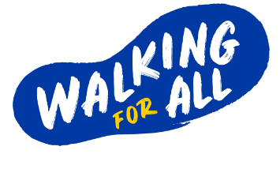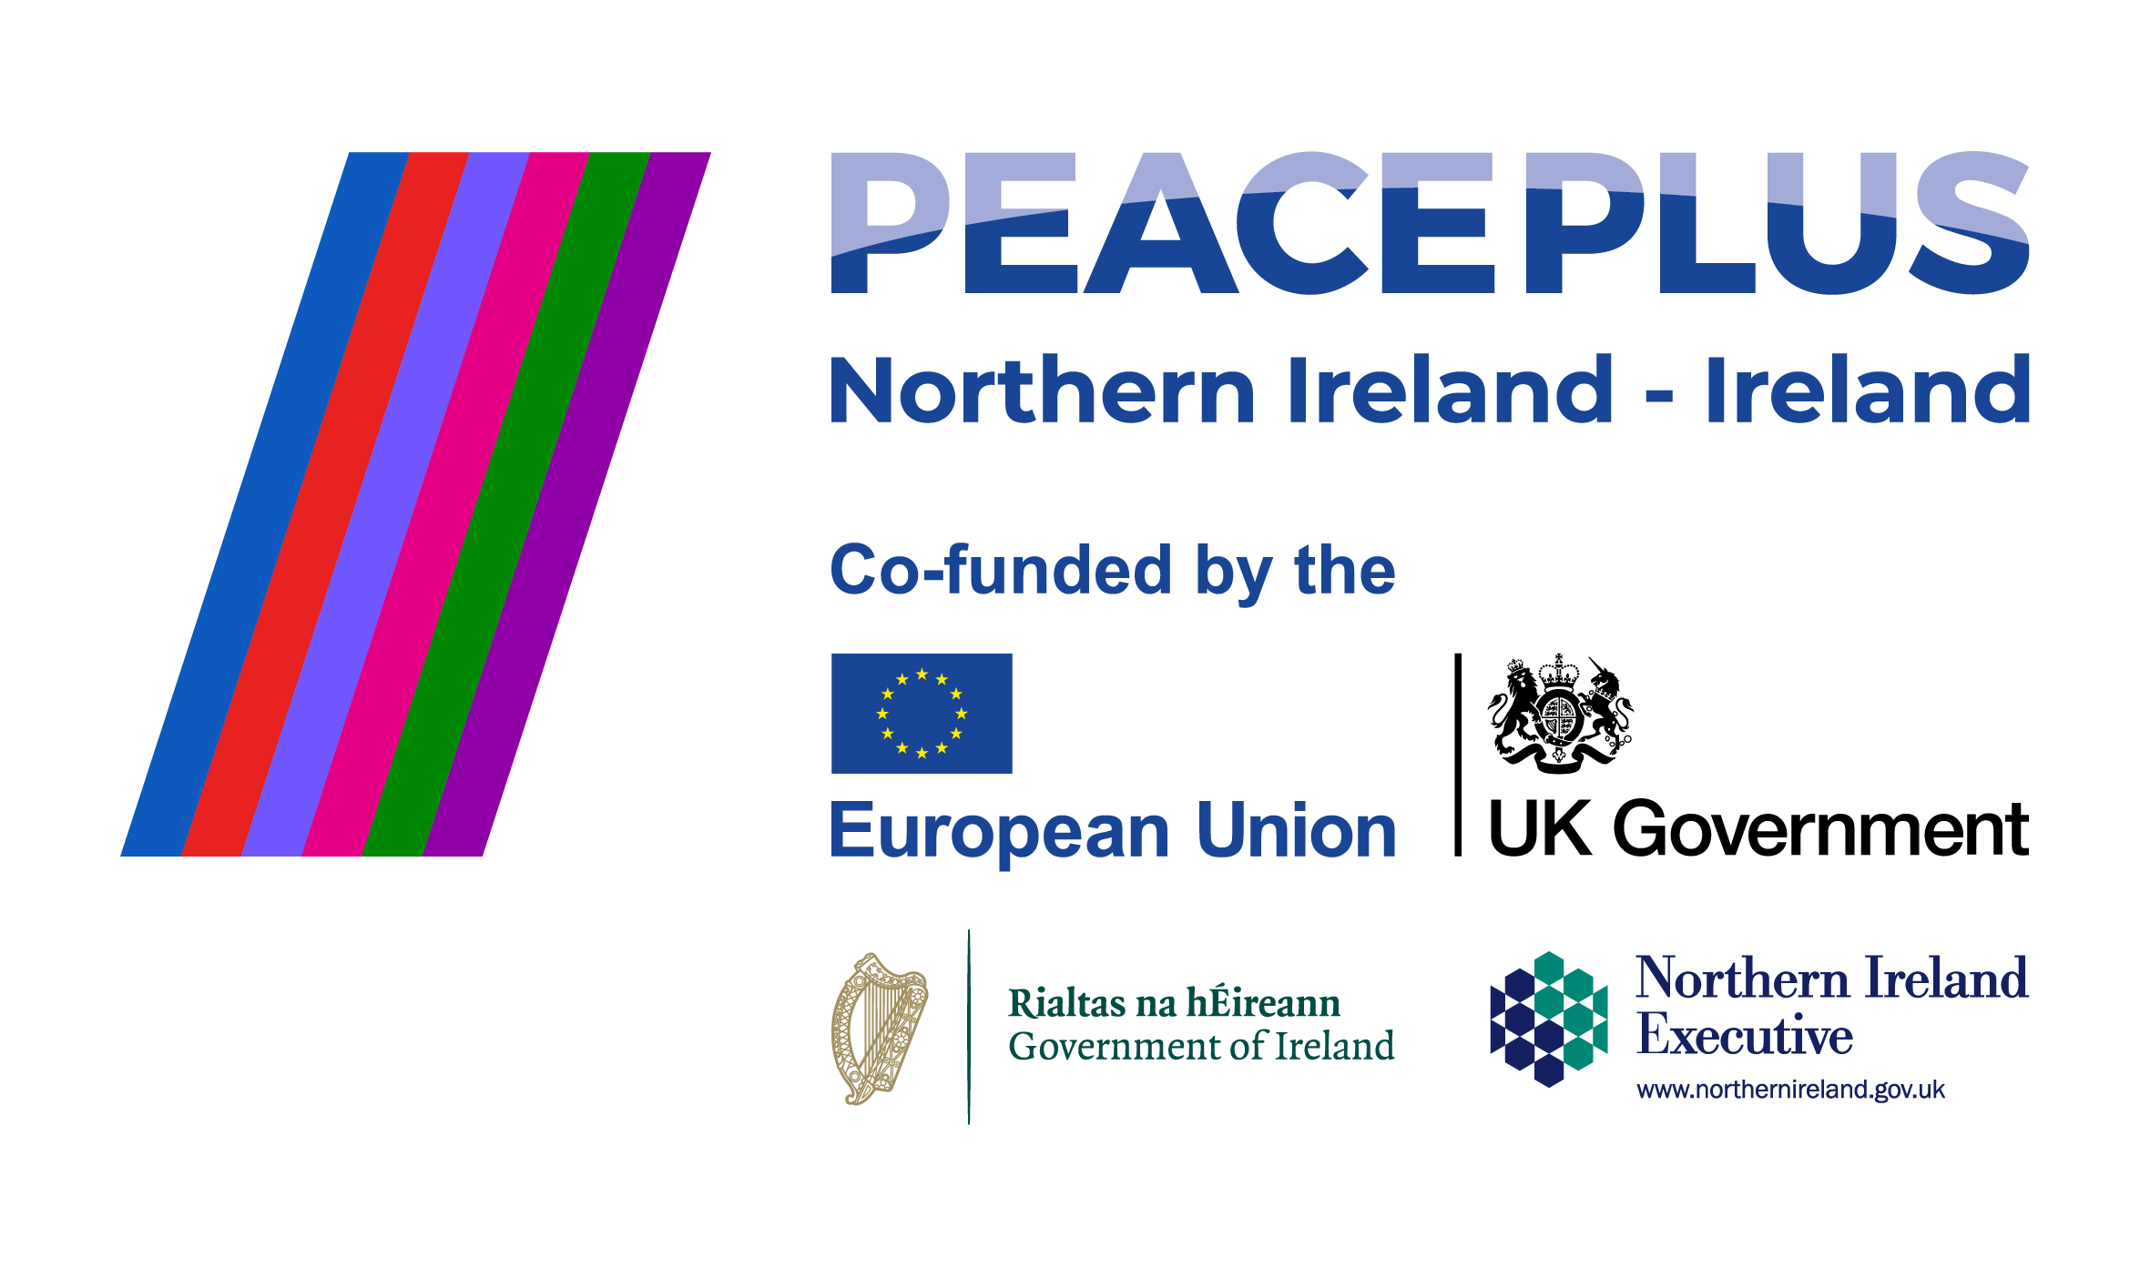

Marketing & Events Executive – Walking for All

£30,024 + flexible benefits package
Hybrid working option – home and Belfast office
Full time, 30-month contract (July 2026 – December 2028) with possibility of extension
Closing Date: Friday 15 May 2026 at midday

The Opportunity
Outscape is a vibrant not-for-profit organisation, striving for a more active and healthy society in the outdoors. Since our establishment in 1999, we’ve been passionate about shaping the outdoors to improve physical and mental health, connect communities and generate economic gain. We have 5 strategic priorities:

1. Championing the Outdoors
2. Delivering Training and Sharing Best Practice
3. Planning and Developing Quality Experiences
4. Increasing Awareness
5. Widening, Increasing and Sustaining Participation

Whilst we have delivered some participation programmes in the past, we now have an opportunity to increase our work in this field at a strategic level as we roll out the Walking for All programme.

This exciting new programme will engage over 14,000 people and volunteers to get walking in rural areas in Northern Ireland and the border counties of Ireland, and is funded by PEACEPLUS, a programme managed by the Special EU Programmes Body. This key strategic initiative will be seminal in tackling endemic societal issues such as physical and mental health, social exclusion and isolation.

The Marketing and Events Executive will play a key role in supporting the delivery of communications and engagement activity across the Walking for All programme. Working closely with the Communications Manager and the wider Walking for All team, this role will focus on managing social media channels, supporting programme events, and ensuring partners and local teams are equipped to promote Walking for All effectively.

The Marketing & Events Executive will also play a lead role in administering the programme database which drives the KPIs for programme impact. This is a varied, hands-on role suited to someone who is organised, creative and comfortable working across multiple projects in a fast-paced, community-focused environment.

You’re excited about this opportunity because you will:

Event Coordination & Delivery
- Lead the planning and delivery of programme events across Northern Ireland and the border counties. This may include supporting Officers with Walk Leader training sessions in local communities, planning activity days or large formal recognition and celebration events
- Coordinate event logistics including sourcing venues, suppliers, materials and the event agenda
- Liaise with internal teams, partners and external providers to ensure smooth delivery
- Provide on-the-day event support

Social Media Management
- Manage and maintain Walking for All social media channels
- Gather, create, schedule and publish engaging content aligned with programme goals and campaigns
- Monitor and respond to messages and comments in a timely and appropriate manner
- Track performance and contribute to ongoing optimisation of content

Content & Asset Development
- Support the creation of marketing materials across print and digital channels
- Develop content for newsletters, toolkits, partner communications and promotional campaigns
- Work with designers and agencies to produce high-quality, on-brand assets
- Ensure content is clear, accessible and suitable for programme audiences

Campaign Support
- Assist with the planning and delivery of marketing campaigns
- Coordinate campaign timelines, assets and partner distribution
- Support local activation through collaboration with Officers and programme partners

Website Support
- Assist with the ongoing development and maintenance of the Walking for All website
- Undertake basic website administration and content updates

Stakeholder Engagement
- Work closely with Walking for All Officers to support local promotion and content gathering
- Liaise with partner communications teams (e.g. councils/LSPs) to coordinate messaging and approvals
- Support the distribution of communications toolkits and campaign materials
- Act as a key point of contact for day-to-day communications queries

Merchandise & Promotion
- Coordinate the procurement and distribution of branded materials and promotional items
- Liaise with suppliers to ensure quality, value for money and brand consistency
- Work with Officers to forecast and manage stock requirements

Data & Administration
- Lead on the daily management and upkeep of the programme database
- Ensure accurate record-keeping and adherence to data processes
- Generate data-driven reports from databases
- Liaise with Officers to address issues related to data capture

Reporting & Evaluation
- Monitor and report on key communications metrics (social media, campaigns, website activity etc)
- Support the evaluation of marketing activity to inform future planning
- Contribute to reporting requirements for stakeholders

General
- Provide administrative and operational support as required
- Contribute to a collaborative and supportive team environment

You will be successful in this role by:
- Taking initiative and ownership of a variety of Marketing and Communications tasks, helping to shape the promotion and public perception of Walking for All, through a proactive, accountable approach
- Embracing the wide network of people engaged in Walking for All, from colleagues to partner organisations, from volunteers to walkers, enabling their communication and celebrating their successes
- Bringing your creative flair to content development
- Being highly organised, detail-oriented, and confident in managing multiple priorities

We’re excited about you because:
You have a minimum of 1 year’s work experience in:
- Supporting the delivery of events
- Managing and executing on social platforms including working with Meta Business Suite
- Creating engaging video and graphic content using content creation tools (such as Canva)
- Working with a wide range of stakeholders with varying communication needs
- Working across and administering a database, CMS or CRM system

Plus,
- Your verbal and written communication skills are exemplary
- You are thorough, consistent and have a high attention to detail
- You have a genuine interest in people becoming active and enjoying the benefits of being outdoors
- You are very proficient in Excel, Word, PowerPoint, and
- You have a full current driving licence and use of a car, or access to a form of transport that allows you to meet the requirements of the role

Compensation
- NJC Scale 5, spine points 15-17 (£30,024) + flexible benefits package
- Based in Belfast office (Barnett Demesne) with option for hybrid working (as set out in Outscape’s Agile Working Policy)
- Unum Health Plan: access to health and wellbeing services, money back on health care expenses
- NILGOSC pension – employer contribution currently 9.3% of pensionable salary; your contribution will be 6.5% (rate may fluctuate slightly based on NILGOSC contribution rate bands)
- 25 days annual leave plus 11 public holidays; opportunity to buy/sell leave days
- Flexible working (as set out in Outscape’s policy)
- Please note: the nature of this role will mean you will have to travel at times within Northern Ireland and the border counties and very occasionally do some evening and weekend work

Application
- Completed application form and equal opportunities monitoring form (applications will not be accepted by any other method and CVs will not be considered) to be submitted by email to roisin@out-scape.com
- Closing date: Friday 15 May 2026 at midday
- If you would like further information on the opportunity, contact Leanne Cromie – Communications Manager (Walking for All) at leanne@out-scape.com to arrange a confidential discussion
- Interviews: Please note that first interviews will take place on 27 May 2026 in Belfast
(Please indicate on the application form if any of these dates are unsuitable)

More about Outscape, Walking for All and PEACEPLUS
Based in Barnett Demesne in south Belfast, Outscape is a small, dynamic not-for-profit organisation focused on the outdoors. We pride ourselves on being a great place to work and have a very high staff retention rate. Currently we have a team of 31 friendly staff who work on a wide range of outdoor recreation projects from developing walking trails to writing strategies to developing marketing campaigns. You can find out more about our vision, our staff and projects on out-scape.com.

Walking for All is a volunteer-led walking participation programme. Whilst we have operated similar programmes in the past, Walking for All is on a more significant scale and has been in development for almost a decade. It is a strategically important programme for Northern Ireland and the border counties and is included in the Department of Health's draft Obesity Strategy in Northern Ireland. Partners include the Public Health Agency, Sport Northern Ireland, Sport Ireland, Mountaineering Ireland and Get Ireland Walking.

Walking for All aims to create healthier rural communities by encouraging participation in walking through organised, volunteer-led walks. These short walks, guided by trained volunteers, will be held in local community spaces and will also aim to bring diverse communities together, fostering acceptance and respect for differences.

Walking for All is funded by PEACEPLUS (€7,536,957) under the Rural Regeneration and Social Inclusion Investment Area, through the PEACEPLUS Healthy and Inclusive Communities theme. PEACEPLUS is a cross-border funding Programme designed to support peace and prosperity across Northern Ireland and the border counties of Ireland. The total value of PEACEPLUS is €1.14 billion. PEACEPLUS is managed by the Special EU Programmes Body (SEUPB) and represents a funding partnership between the European Union, the Government of the United Kingdom of Great Britain and Northern Ireland, the Government of Ireland, and the Northern Ireland Executive.

